A Systematic Literature Review of Digital Twin Applications for Design-for-Safety and Design-for-Quality in the AECO Industry: Toward a Self-Improving Cognitive Digital Twin

Author: Hu TianYu, Department of Architecture and Civil Engineering, City University of Hong Kong
Supervisor: Prof. Thomas Ng
Version: v0 [20260727]

Abstract
[250–300 words, structured abstract — write LAST]
- Background: 1–2 sentences on DT fragmentation problem in AECO
- Objective: State the SLR's dual purpose — map DT-DfX landscape + identify Cognitive/Self-Improving DT gap
- Methods: 3 databases (Scopus n=376, WoS n=180, Lens n=51 → dedup 486 → included n=___), PRISMA 2020, VOSviewer 1.6.20
- Findings: 3–4 key findings (thematic clusters, temporal trends, methodology gaps)
- Contribution: Position the identified gap → set up the PhD research
- Keywords: Digital Twin; Cognitive Digital Twin; Design-for-Safety; Design-for-Quality; AECO; Systematic Literature Review; Bibliometric Analysis

Introduction

The AECO Industry's Phase-Fragmented Delivery Problem
Digital Twin concept is originally proposed by M. Grieves et al. [1] as a mechanism for mitigating unpredictable emergent behavior in complex systems. It has rapidly evolved into a strategic paradigm for the digital transformation of infrastructure sectors. Within the Architecture, Engineering, Construction, and Operations (AECO) industry specifically, Boje et al. [2] proposed a semantic construction digital twin framework and explicitly identified cross-phase integration and cognitive adaptation as critical unaddressed challenges, while D. J. Opoku et al. [3] mapped the diverse but fragmented application landscape across various phases of construction projects. The previous study and discussions on digital twin is enormous and broadly distributed into various phases of life cycle and application fields with dispersed purposes. Building upon these foundational contributions, this study aims to review the current state of DT application and the barriers preventing its further development towards high intelligence. TBD

Preliminary Research Gaps
- An evident conceptual-implementation gap exists in widely cited application frameworks. Existing cognitive DT frameworks propose self-improvement conceptually but do not formalise convergence. For examples, F. Tao et al. [4] proposes a conceptual function is proposed to describe the digital twin M_{DT}= f (Physical Entity, Virtual Entity, services; DT Data, connections) but it lacks convergence. Zheng et al. [5] introduces iterative optimisation concept yet does not demonstrate self-updating mechanism nor convergence criterion. A contrasting variant of the same gap is that Lu et al. [6] in their DT-enabled anomaly-detection system for building O&M, adopt Bayesian on-line change-point detection deliberately because it does not require "prior knowledge of pre-change or post-change operation processes". It contains no mechanism for the digital twin to update its own model from operational data, leaving the self-improving convergence unaddressed.
- Existing closed-loop BIM by Pärn et al. [7] feeds operation data back episodically without iteration. Knowledge-based feedback loop is proposed that return operational performance data from the O&M phase to designers and contractors but at one time without iteration, self-learning and is not instantiated. The mechanism by which such feedback would be continuously converged toward improved cross-phase decisions is left entirely unaddressed.
- Based on the above preliminary findings, it is initially observed that cross-phase DT with forward prediction and convergence and backward self-improvement is unaddressed.

Research objectives
To address the gap identified above, this review pursues three research objectives (RO):
RO1.
To systematically map the bibliometric landscape of digital-twin research addressing design-for-safety and design-for-quality in the AECO sector.
RO2.
To expose the current capability and deficiencies of digital twin against the criteria of forward prediction, convergence and self-improvement.
RO3.
To formulate a research agenda aiming to address the identified gaps and delineate the requirements for a self-improving cognitive digital twin (CDT).

Research Questions
Guided by these objectives, the review is structured around four research questions (RQ) are defined below.
RQ1:
What is the current scope, thematic structure, and evolution of DT research addressing the forward prediction capability, taking the design, safety and quality as carrier factors?
RQ2:
Which methodological approaches (GNN, LLM, BN, ABM, etc.) has the potential to realize and integrate the conceptual self-improving DT frameworks, and which are underexplored?
RQ3:
To what extent does existing DT research exhibit self-improving, cross-phase, or convergence-guaranteeing properties?
RQ4:
What are the theoretical, methodological, and empirical gaps that motivate a self-improving CDT framework?

Background

Digital Twin: Definitional Landscape
[Table 1: DT / Digital Shadow / Digital Model / Cognitive DT / CPS — comparison matrix, columns: definition, direction of data flow, autonomy level, seminal reference]

Design-for-X (DfX) in AECO
[~300 words. Trace DfS (Prevention through Design, safe design), DfQ (defect / rework), DfMA, DfSustainability. Justify the SLR's scoping decision to focus on DfS + DfQ.]

The "Cognitive" Turn: Self-Improving and Convergence-Aware Systems
[~300 words. Bridge from manufacturing/aerospace cognitive DT (Lu, Zheng) to expert-iteration/self-play (Silver 2017) → set up why AECO has not caught up.]

Research Methodology

Review Protocol
The literature review follows PRISMA 2020 [8] integrated with bibliometric analysis using VOSviewer 1.6.20 [9] by adopting the "Bibliometric-SLR" hybrid methodology [10]. Scopus database is selected as it is widely used for similar studies in the field due to comprehensiveness.

Eligibility Criteria
Table 1 Searching Eligibility Criteria
Criterion | Inclusion | Exclusion
Domain | AECO / built environment | Manufacturing, automotive, aerospace
Topic | DT + DfS or DfQ as primary focus | DT as buzzword
Publication type | Peer-reviewed journal article | Editorial, opinion piece, books
Language | English | Non-English
Period | 2015 to June 2026 | Pre-2015, after July 2026

Query 1:
Scopus: TITLE-ABS-KEY ( "digital twin" OR "cognitive digital twin" OR "digital shadow" ) AND TITLE-ABS ( safet* OR "design for safety" OR "prevention through design" OR incident* OR accident* OR hazard* OR defect* OR rework ) AND ( TITLE ( AEC OR AECO OR construct* OR "civil engineering" OR BIM OR building* OR infrastructur* OR "built environment" OR "built asset" ) OR KEY ( AEC OR AECO OR construct* OR "civil engineering" OR BIM OR building* OR infrastructur* OR "built environment" OR "built asset" ) ) AND PUBYEAR > 2014 AND PUBYEAR < 2027 AND ( LIMIT-TO ( SUBJAREA , "ENGI" ) ) AND ( LIMIT-TO ( DOCTYPE , "ar" ) )

Web of Science: TS=("digital twin" OR "cognitive digital twin" OR "digital shadow") AND TS=(safet* OR "design for safety" OR "prevention through design" OR incident* OR accident* OR hazard* OR defect* OR rework) AND (TI=(AEC OR AECO OR construct* OR "civil engineering" OR BIM OR building* OR infrastructur* OR "built environment" OR "built asset") OR AK=(AEC OR AECO OR construct* OR "civil engineering" OR BIM OR building* OR infrastructur* OR "built environment" OR "built asset"))
AND PY=2015-2026 AND DT="Article"

Two-Layer Corpus Structure
Table 2 - Layer 1 of Primary Analytical Corpus
Source | Database search (Scopus + Web of Science)
Criteria | Query 1 + eligibility criteria
Theme | DT + AECO + safety/defect/rework
Number | ~490 (after dedup + screening)
Source | Section 4 Bibliometric analysis + Section 5 Thematic synthesis
Analysis conducted | Title, key words and abstract; and  PRISMA screening

Table 3 - Layer 2 of Supplementary Theoretical Foundations
Source | Backward snowballing via co-citation analysis
Criteria | Co-citation threshold ≥5 or distinct methodological role
theme | General DT theory + Reinforced Learning methodology + BIM foundations
Number | Total 12 nos. publications (9 + 3 补)
Used for | Section 2 Background + Section 6 Discussion
Analysis conducted | Full text in-depth analysis

Table 4 List of publications Added via Backward Citation Searching as Layer 2 Supplement
ID | Reference | Co-citation Freq.  (in Layer 1) | Theoretical Role | Reference no.
L2-01 | Rezgui/Boje et al. (2020). Towards a semantic construction digital twin: Directions for future research | 13 | Construction DT domain integration; semantic layer articulation | [2]
L2-02 | Grieves M. (2014). Digital twin: Manufacturing excellence through virtual factory replication | 5 | Original AECO-adjacent DT conceptualization | [11]
L2-03 | Grieves M. & Vickers J. (2017). Digital Twin: Mitigating unpredictable, undesirable emergent behavior in complex systems. | 10 | Cognitive DT and emergent behavior theory | [1]
L2-04 | Barlow C. et al. Digital twin: Enabling technologies, challenges and open research issues | 8 | Technology enablers framework | [12]
L2-05 | Flath C.M. et al. Peeking into the void: Digital twins for construction site logistics. | 5 | Construction site logistics DT (applied domain) | [13]
L2-06 | Girolami M. et al. Construction with digital twin information systems. | 7 | Data-centric DT information systems | [14]
L2-07 | Holmstrom J. et al. Digital twin: Vision, benefits, boundaries, and creation for building. | 7 | DT vision and boundaries for AECO | [15]
L2-08 | Kvamsdal T. et al. Digital twin: Values, challenges and enablers from a modeling perspective. | 7 | Modeling perspectives and value proposition | [16]
L2-09 | Hicks B. Characterising the digital twin: A systematic literature review | 5 | DT characterization taxonomy | [17]
L2-10 | Grieves M.W. (2005). Product Lifecycle Management: The new paradigm for enterprises. | 3 | Original PLM formulation—earliest DT concept articulation | [18]
L2-11 | Sutton R.S. & Barto A.G. Reinforcement Learning: An Introduction | 3 | Reinforcement learning methodology foundation for Objective 2 | [19]
L2-12 | Kritzinger W., Karner M., Traar G., Henjes J., Sihn W. (2018). Digital Twin in Manufacturing: A Categorical Literature Review and Classification. | 4 | DT/DS/DM three-tier categorization | [20]

Screening Process
Describe Rayyan / Covidence workflow, pilot screening on 20 papers to calibrate inter-rater judgment (even if solo, self-calibration matters), Cohen's κ if applicable.

Backward Citation Searching via Co-citation Analysis
Following the PRISMA 2020 template with snowballing in systematic literature studies, supplementary citation searching was conducted to complement the primary database search. The snowballing procedure comprised two components:
  - A systematic co-citation analysis was performed in VOSviewer 1.6.20 on the Scopus subset of the corpus (n=383) to identify foundational works of the field. Two thresholds were sequentially applied:
  - Primary threshold (co-citation ≥ 5): A total of 21 cited-reference entries met this threshold, corresponding to 16 unique publications after manual deduplication of variant citation formats. Of these, 9 unique publications were identified as not yet included in the primary corpus and therefore manually added as Layer 2 supplementary theoretical foundations, they are:
    - Rezgui/Boje et al. (2020, semantic construction DT);
    - Grieves & Vickers (2017, mitigating emergent behavior);
    - Grieves M. (2014, DT for manufacturing excellence);
    - Barlow C. (DT enabling technologies);
    - Flath C.M. (DT for construction site logistics);
    - Girolami M. (construction with DT information systems);
    - Holmstrom J. (DT vision and boundaries);
    - Kvamsdal T. (DT values and challenges); and
    - Hicks B. (characterising the digital twin).
  - Supplementary methodological threshold (co-citation ≥ 3 with distinct theoretical role): A further set of 3 references achieving co-citation frequency between 3 and 4 were identified as methodologically indispensable for the review's argumentation and added following van Eck & Waltman's (2014) guidance for supplementary theoretical inclusion in emerging-field bibliometric reviews: Grieves M.W. (2005, the original PLM formulation that constitutes the earliest articulation of the DT concept and is required for Section 2.1); Sutton R.S. & Barto A.G. (2018, Reinforcement Learning: An Introduction, the foundational methodological reference for the RL-based convergence loop in Objective 2); and Kritzinger W. et al. (2018, DT/DS/DM categorical classification, required for the Section 2.1 taxonomy). Each of these 3 supplementary references was justified by a unique theoretical role that could not be fulfilled by references already in the primary corpus.
  - In total, 12 supplementary theoretical foundations were added to the review via backward citation searching, constituting Layer 2 of the two-layer corpus structure (Section 3.4). These 12 supplementary references serve as theoretical anchors in Sections 2 (Background) and 6 (Discussion) rather than as analytical objects of the systematic synthesis in Sections 4 and 5, in accordance with the two-layer corpus methodology (Marzi et al., 2024).

Forward citation searching
For each of the 20 most-cited papers, Google Scholar's 'Cited by' function was queried to identify recent publications (2024-2026) that may not yet have been indexed in Scopus, WoS, or Lens.org at the search date. Retrieved records were screened against the same eligibility criteria.
The snowballing search was conducted on 6 July 2026 and yielded [N_backward] additional pre-2021 foundational studies (including Grieves & Vickers, 2017; Boschert & Rosen, 2016; Boje et al., 2020) and [N_forward] additional recent studies. All added studies are marked in the final data extraction table (Appendix C) with the source of identification."

Analysis Methods
- Bibliometric: keyword co-occurrence, co-authorship, source coupling (VOSviewer)
- Thematic: inductive coding of methodology, DfX target, and DT capability tier
- Gap analysis: 3-dimensional matrix (temporal × methodological × cross-phase scope)

PRISMA 2020 Flowchart
[Figure 1: PRISMA 2020 flow diagram]
Identification of studies via databases and registers

Records removed before screening:
- Duplicate records removed (n = 169)
- Records marked as ineligible by automation tools (n = )
- Records removed for other reasons (n = )
Records identified from*:
Scopus (n = 381)

Identification

Records screened
(n = )
Records excluded**
(n = )

Reports sought for retrieval
(n = )
Reports not retrieved
(n = )

Screening

Reports assessed for eligibility
(n = )
Reports excluded:
Reason 1 (n = )
Reason 2 (n = )
Reason 3 (n = )
etc.

Studies included in review
(n = )
Reports of included studies
(n = )
Included

Descriptive and Bibliometric Findings (RQ1)

Publication Trends

Year | Pub-  lication nos. | 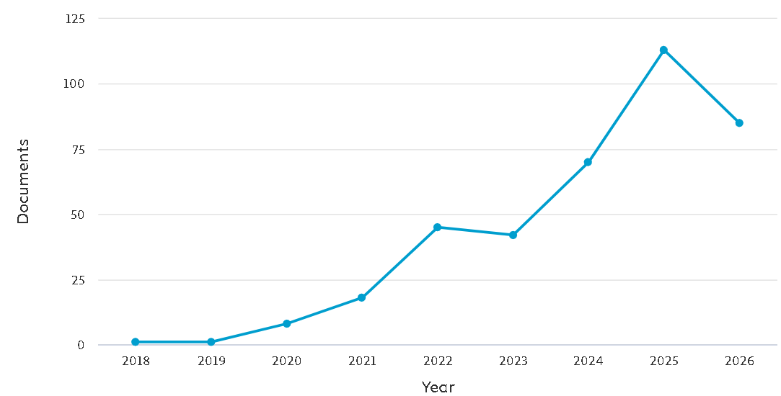
Jan to Jun 2026 | 83
2025 | 113
2024 | 70
2023 | 42
2022 | 45
2021 | 18
2020 | 8
2019 | 1
2018 | 1
total | 381
Figure 1. Annual Publication nos. 2015-2026
Figure 1 presents the annual distribution of the 381 identified publications on Digital Twin in AECO addressing safety, quality, defect, and incident-related outcomes (2019–2026). The corpus exhibits an exponential growth trajectory from a single publication in 2019 to 113 publications in 2025, with 83 additional publications identified in the first half of 2026 alone. This surge reflects several converging drivers: (i) the theoretical consolidation of Digital Twin frameworks following seminal AECO-specific formulations by Boje et al. [2] and Sacks et al. [14]; (ii) the industry-wide digitalization acceleration due to developed enabling technologies [21]; and (iii) the growing safety [22] and quality [23] demands imposed by increasingly complex infrastructure projects.

Temporal Evolution of Research Themes

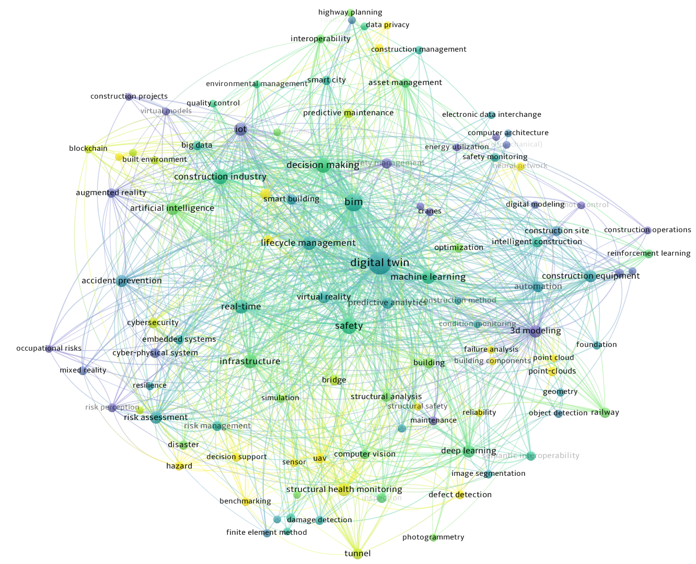
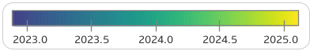
Figure 2 Publication Trends in themes

Figure 2 presents the overlay visualization of the keyword co-occurrence network, with node colour representing the average publication year of each keyword (ranging from 2023.0 to 2025.0). This temporal overlay reveals three distinct thematic phases in the recent evolution of DT-in-AECO research.

Phase 1 Foundational Consolidation (2023, purple nodes)
The earliest thematic cluster visible in the corpus is anchored by cyber-physical system, embedded systems, virtual models, computer architecture, mixed reality, 3d modeling, neural network, condition monitoring, and occupational risks. These keywords represent the mature foundational infrastructure of DT research, upon which more recent developments have built.

Phase 2 — Current Mainstream (2024, green nodes)
The central cluster of the network is dominated by digital twin, BIM, safety, machine learning, artificial intelligence, IoT, real-time, deep learning, risk assessment, infrastructure, construction industry, and lifecycle management. This phase represents the active mainstream of contemporary research, characterized by BIM–DT–AI integration for construction management and safety applications.

Phase 3 — Emerging Frontier (2025, yellow nodes)
The most recent thematic cluster features reinforcement learning, defect detection, damage detection, structural safety, structural health monitoring, predictive maintenance, intelligent construction, construction operations, image segmentation, point-clouds, blockchain, and data privacy. These nodes represent the current research frontier, characterized by the integration of reinforcement learning with defect and damage detection.
The temporal overlay reveals two critical structural observations relevant to the research gap identified in this review. First, the keywords most closely aligned with the present dissertation's objectives—reinforcement learning (Objective 2's core methodology) and defect detection (Objective 1's primary prediction target)—both exhibit the highest average publication years (>2024), positioning the proposed research directly within the emerging research frontier. Second, the notable absence from the visualization of keywords explicitly denoting cognitive digital twin, self-improving, or cross-phase convergence, all below the analysis threshold of 5 occurrences, empirically confirms that these specific formulations remain new even within the 2025 frontier. This dual observation is that the emergence of adjacent enabling technologies alongside the absence of integrated cognitive-convergence frameworks defines the precise theoretical gaps that the proposed research objective seeks to address.

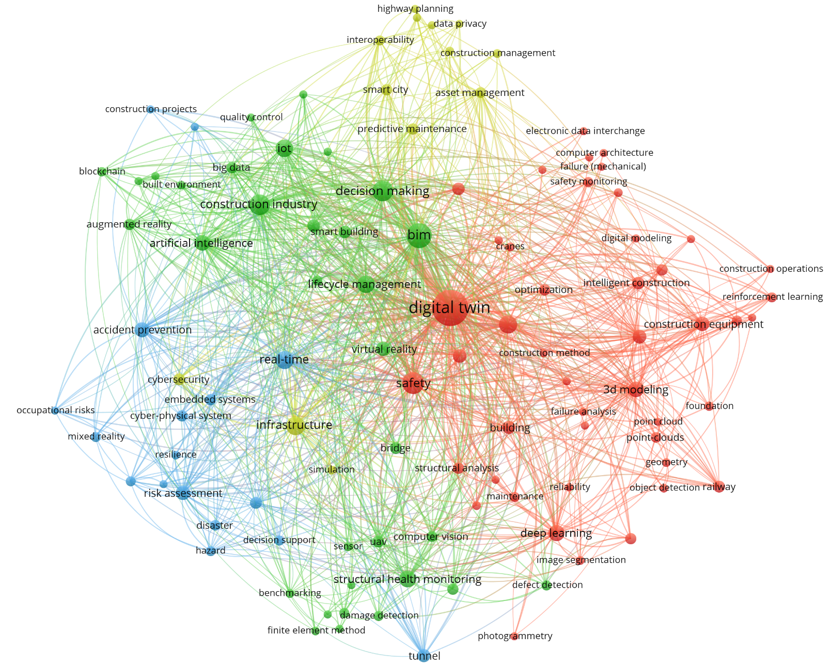
Keyword Co-Occurrence Map
Figure 3 Keyword Co-occurrence Network
The keyword co-occurrence network (Figure 3) is constructed using VOSviewer with the full-counting method, applying a minimum occurrence threshold of 5 to 3,786 unique keywords after thesaurus-based normalisation, resulting in 109 keywords retained. Node size represents keyword frequency; node colour indicates cluster membership determined by the VOS clustering algorithm (resolution = 0.80); edge thickness represents the strength of co-occurrence between keyword pairs. The analysis identified four thematic clusters, revealing the intellectual structure of digital twin research in the AECO industry.
Cluster 1 Digital Twin Core, AI, and Automated Sensing (red):
Anchored by digital twin (257 occurrences, the largest node) and integrating safety (52 occurrences), machine learning, deep learning, real-time, and reinforcement learning, this cluster represents the intellectual core of the field. It integrates AI-driven sensing technologies (3D modelling, point cloud, photogrammetry, object detection, image segmentation) with construction safety applications (safety monitoring, defect detection, damage detection, structural safety) and specific engineering contexts (construction equipment, intelligent construction, railway, excavation).
Cluster 2 Risk Assessment, SHM, and Accident Prevention (blue):
Featuring risk assessment, risk management, risk analysis, risk perception, hazard, disaster, resilience, and accident prevention, this cluster represents the DfS-oriented risk analytics stream. Structural monitoring aspects are represented by structural health monitoring, structural analysis, bridge, and tunnel. Methodological support is provided by Bayesian networks, finite element method, mixed reality, and embedded systems. This cluster reflects the field's transition from descriptive safety monitoring toward predictive, model-based risk analytics.
Cluster 3 — Infrastructure DT and Cybersecurity (yellow):
Centred on infrastructure, predictive maintenance, asset management, and smart city, this cluster addresses DT deployment at the infrastructure scale. Emerging operational concerns include cybersecurity, interoperability, edge computing, and data privacy. Transportation infrastructure sub-topics (motor transportation, roads and streets) form a distinct peripheral community within this cluster, reflecting DT applications in intelligent transport systems.
Cluster 4 — BIM, AI Decision Support, and Smart Building (green):
Comprising BIM (75 occurrences, the second-largest node), construction industry, information management, decision making, artificial intelligence, IoT, big data, and lifecycle management, this cluster represents the BIM-anchored DT paradigm. It extends into immersive technologies (augmented reality, virtual reality, virtual models), emerging technologies (blockchain, electronic data interchange), and sustainability applications (smart building, sustainability, built environment, energy efficiency, quality control). This cluster reflects the traditional information-management view of DT as a BIM extension supporting whole life-cycle decision-making.
The network reveals three important structural observations. First, digital twin occupies the geometric centre of the network with the highest total link strength, indicating that DT-in-AECO research is thematically well-integrated rather than fragmented across sub-fields. Second, the two largest secondary nodes — BIM and safety — sit at the boundary of Clusters 1, 2, and 4, confirming BIM and safety as the dual foundational concepts organising the field. Third, the network reveals a notable absence of dominant nodes explicitly addressing self-improving, cognitive, or convergence-aware DT capabilities (fewer than 4 occurrences each, below the analysis threshold), empirically confirming the research gap that motivates this review — namely, that despite widespread DT adoption in AECO, formal self-improving cross-phase DT frameworks with convergence guarantees remain a substantially under- explored territory.

Co-citation Network Analysis

Scopus records

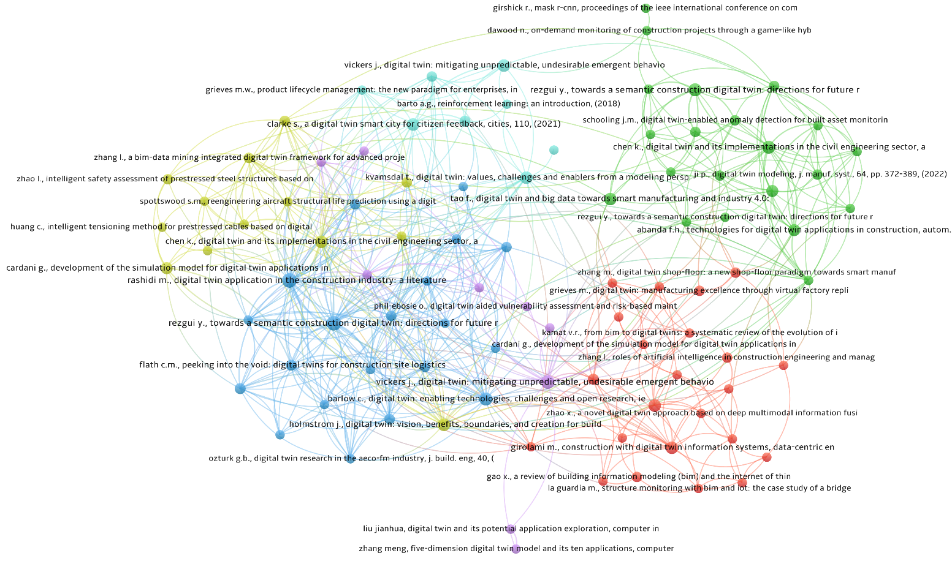
The observation that only 3 references achieve co-citation frequencies of 10 or higher out of 17,899 total unique cited references (0.017%) is itself a defining characteristic of the field. This extreme dispersion reflects the emerging nature of DT-in-AECO research and indicates that the theoretical foundation is still consolidating. In this context, the present dissertation contributes to shaping the field's evolving canon rather than incrementally extending established paradigms
Figure 4 Co-citation network of Scopus records

The co-citation network (Figure 4) of foundational works cited by the 383 corpus studies. Applying a minimum co-citation threshold of 3, 94 references were identified as belonging to the field's foundational knowledge base, organized into six thematic clusters. The network exhibits a distributed multi-centric structure, which means the knowledge in the field is yet consolidated to be commonly accepted outcomes.
Cluster 1 Manufacturing DT and BIM Integration (red, 23 items):
The largest cluster, anchored by Grieves M. (2014), Zhang M. (shop-floor DT), Girolami M. (data-centric construction), and Kamat V.R. (BIM to DT). This cluster represents the intellectual origin of DT theory in manufacturing and its foundational translation into BIM-anchored AECO applications.
Cluster 2 Civil Engineering DT and Anomaly Detection (green, 21 items):
Anchored by Rezgui/Boje et al. (2020), Schooling J.M. (anomaly detection), Chen K. (civil engineering implementations), and Tao F. (DT + big data). Notably, this cluster contains Girshick R.'s Mask R-CNN—a computer vision reference indicating DT's methodological borrowing from adjacent AI fields.
Cluster 3 BIM Foundations and Construction Site DT (blue, 20 items):
Featuring Barlow C. (enabling technologies), Flath C.M. (construction site logistics), Kassem M. (built environment), Ozturk G.B. (AECO-FM industry), and Taylor C. (civil engineering 4.0). This cluster represents the BIM-anchored view of DT as an information management extension.
Cluster 4 DT Applied Reviews and Structural Applications (yellow, 13 items):
Anchored by Stargel D. (Glaessgen & Stargel 2012, NASA foundational paper), Nee A.Y.C., Huang C. (prestressed cables intelligent tensioning), Zhao L. (prestressed steel intelligent safety), and Vickers J. (mitigating emergent behavior—appearing here for the first time). This cluster bridges concept-oriented and application-specific DT works, particularly for structural safety.
Cluster 5 Cognitive DT and Vulnerability Assessment (purple, 9 items):
Comprising Bettenhausen K.D. (importance of autonomy), Phil-Ebosie O. (DT-aided vulnerability assessment), Zhang Meng (five-dimension DT model), and Vickers J. (again). This cluster represents the emerging stream integrating cognitive DT capability with structural vulnerability analysis.
Cluster 6 Foundational Theoretical References (cyan, 8 items):
The smallest cluster yet the most conceptually critical, comprising Grieves M.W. (2005 PLM formulation as being the earliest DT concept articulation), Vickers J. (2017, DT for emergent behavior), Barto A.G. (2015, Reinforcement Learning: An Introduction), Xu C. (comprehensive DT review), Kvamsdal T. (DT modeling perspectives), and Spencer B.F. (post-earthquake applications). This cluster functions as the field's meta-theoretical foundation, integrating the original DT formulation with methodological references and comprehensive review works.

Three observations can emerge from the co-citation network. First, the distributed multi-centric structure across six clusters reflects the ongoing theoretical consolidation of DT-in-AECO. Second, several references, notably Rezgui/Boje (2020), Kamat V.R., Chen K., and Vickers J., appear in multiple clusters, indicating their role as integrative works that bridge distinct theoretical fields. Third, Cluster 6 simultaneously contains the field's conceptual origin (Grieves 2005), cognitive theoretical foundation (Vickers 2017), and adjacent methodological of reinforcement learning (RL) (Barto 2015). The presence of an RL reference in the field's foundational position confirms that RL is already recognized as an adjacent methodological tradition for DT-in-AECO applications. Concurrently, the size of Cluster 6 is much smaller application-oriented Clusters 1 to 3, which confirms that the cognitive and RL-based DT remains a substantially underdeveloped frontier.

WoS records
Document co-citation analysis was performed on the Scopus subset to expose the intellectual base upon which the field is constructed. Applying a minimum co-citation threshold of five, the analysis resolved the corpus into four distinct clusters, each representing a coherent knowledge foundation whose composition is summarised below and interpreted thereafter.
The first cluster constitutes the theoretical and manufacturing origins of the digital-twin paradigm. It is anchored by the foundational conceptualisations of Grieves and Vickers [x] and the model–shadow–twin taxonomy of Kritzinger et al. [x], flanked by the manufacturing-oriented contributions of Tao et al. [x], [x]. The prominence and centrality of these nodes confirm that the field's conceptual vocabulary is inherited largely from product-lifecycle and manufacturing engineering rather than originating within AECO. The second cluster occupies the network's bridging region and captures the translation of DT into construction management and application, exemplified by Jiang et al. [x], Pan et al. [x], and Tuhaise et al. [x]. The third cluster represents the construction-specific DT review and computer-vision methodological base, gathering the synthesising works of Boje et al. [x], Opoku et al. [x], and Sacks et al. [x] alongside—and this is analytically significant—canonical computer-vision references (e.g., Ren et al. [x]; Zhang et al. [x]) that originate entirely outside the built environment. The fourth cluster consolidates the BIM and semantic-web foundations, centred on Pauwels et al. [x] and associated deep-learning-for-construction contributions.
Four observations of consequence for this review emerge from the network's topology. First, the field possesses a clearly identifiable and consensual theoretical origin: the co-citation prominence of Grieves and Vickers [x] and Kritzinger et al. [x] at the interface of the first and second clusters demonstrates that these works function as the shared conceptual root across otherwise distinct sub-communities, and thereby retrospectively legitimises the adoption of the Kritzinger capability taxonomy as the organising lens of the present synthesis (§5.1). Second, and most tellingly, the manufacturing-origin cluster and the construction-application cluster occupy opposing extremes of the network with comparatively sparse inter-cluster linkage; this structural separation provides direct bibliometric evidence that the technical foundations of DT developed in manufacturing have not yet been fully assimilated into AECO practice, and that knowledge transfer between the two remains incomplete. Third, the embedding of general-purpose computer-vision classics within the construction cluster reveals that methodological advances in the field are predominantly borrowed from generic deep-learning research rather than developed as domain-native cognitive mechanisms—a pattern that corroborates the methodological findings reported for RQ2 (§5.4). Fourth, the near-total concentration of high-weight nodes within the 2017–2023 window, with only isolated earlier computer-vision references, indicates a young and rapidly consolidating field whose intellectual base has not yet sedimented into a mature canon.
The most consequential finding, however, is defined by absence rather than presence. The co-citation network exposes well-formed foundations for DT conceptualisation, for construction application, for computer-vision methodology, and for BIM integration—yet it contains no co-cited foundation addressing self-improvement, self-learning, or convergence. No node, and no cluster, coalesces around the notion of a digital twin that autonomously and iteratively updates its own predictive models toward a demonstrable convergence criterion. This structural void is not an artefact of the analysis but its most substantive result: it demonstrates that a self-improving cognitive DT paradigm has yet to establish an intellectual base within AECO. This finding directly anticipates and reinforces the thematic gap developed in Section 5, where the closer reading of the three works that come nearest to the concept—Pärn et al. [x], who articulate a knowledge-based feedback loop only as an unrealised, unidirectional schematic; Zheng et al. [x], who assert iterative optimisation at the architectural level while demonstrating only real-time monitoring; and Lu et al. [x], who deliberately circumvent learning in favour of static statistical detection—confirms at the level of individual studies what the co-citation network reveals at the level of the field as a whole: the intellectual foundation for a convergence-aware, cross-phase self-improving cognitive digital twin does not yet exist, and it is precisely this foundation that the present research programme sets out to establish.

Thematic Synthesis (RQ2 and RQ3)

Digital Twin Capability Tiers in AECO
[Introduce a taxonomy — e.g., Tier 1 Digital Model, Tier 2 Digital Shadow, Tier 3 Digital Twin (bidirectional), Tier 4 Cognitive DT (autonomous). Classify the 486 → included corpus.]
[Table 6: capability tier distribution]

Design-for-Safety Applications

Hazard prediction and prevention through design

Real-time safety monitoring

Incident forensics and knowledge feedback

Design-for-Quality Applications

Defect prediction from design geometry

Rework and quality control loops

Cross-discipline (Structural / Envelope / MEP) quality integration

Self-Improving and Convergence-Aware Systems
[Explicitly separate the ~5–15 papers that even mention self-improvement / closed loop / convergence. Show that formal convergence characterisation is essentially absent.]

Discussion (RQ4)

What is Working: Consolidated Progress
[~350 words — celebrate what has advanced: BIM-IFC integration, YOLO-based site monitoring, LLM-enabled safety knowledge extraction]

Persistent Gaps

Gap 1 — Absence of formal convergence guarantees in cross-phase DT

Gap 2 — Single-modality dominance vs. proposal's multi-modal ambition

Gap 3 — Single-phase (mostly operation) dominance vs. life-cycle integration need

Gap 4 — No unified DfS + DfQ predictor at element level

Gap 5 — Lack of empirical validation on real cross-project AECO data

Conceptual Framework for a Self-Improving Cognitive Digital Twin
[Figure 6: proposed conceptual framework — publication-ready SVG]
Reference to the two-objective coupling in the proposal:
- Objective 1 as forward predictor
- Objective 2 as iterative convergence loop

Research Agenda
[Present 5–7 numbered future research directions — each mapped back to Gaps 1–5 above]

Conclusions
[~300 words. Recap RQ1–RQ4 answers, restate the identified gap, and set up the PhD research contribution — this section is where you seed the reader to expect Chapter 3 (methodology) of the thesis.]

Implications for practice and future research
Dd
8.2 Limitations of this study
- Database coverage: 3 sources, English-only, DOI-indexed
- Timeframe: 2015–2026 (early DT-in-AECO grey literature excluded)
- Single reviewer (solo PhD) — mitigated by pilot screening and PRISMA transparency
- VOSviewer clustering sensitivity to occurrence threshold
- Grey literature and patents excluded

Declaration of Competing Interest
The authors declare that they have no known competing financial interests or personal relationships that could have appeared to influence the work reported in this paper.

References
[Use Elsevier's numbered style (or your target journal's). Target: 120–180 refs for a top-tier SLR.]

Target words count: total 15,000, main body 10,000, reference 5,000

[1] M. Grieves and J. Vickers, "Digital Twin: Mitigating Unpredictable, Undesirable Emergent Behavior in Complex Systems," (in en), pp. 85-113, 2017 2017, doi: 10.1007/978-3-319-38756-7_4.
[2] C. Boje, A. Guerriero, S. Kubicki, and Y. Rezgui, "Towards a semantic Construction Digital Twin: Directions for future research," Automation in Construction, vol. 114, 2020, doi: 10.1016/j.autcon.2020.103179.
[3] D. J. Opoku, S. Perera, R. Osei-Kyei, and M. Rashidi, "Digital twin application in the construction industry: A literature review," (in English), Journal of Building Engineering, vol. 40, Aug 2021, doi: 10.1016/j.jobe.2021.102726.
[4] F. Tao, M. Zhang, Y. Liu, and A. Y. C. Nee, "Digital twin driven prognostics and health management for complex equipment," CIRP Annals, vol. 67, no. 1, 2018/01/01, doi: 10.1016/j.cirp.2018.04.055.
[5] Y. Zheng, S. Yang, H. Cheng, Y. Zheng, S. Yang, and H. Cheng, "An application framework of digital twin and its case study," Journal of Ambient Intelligence and Humanized Computing 2018 10:3, vol. 10, no. 3, 2018-06-18, doi: 10.1007/s12652-018-0911-3.
[6] Q. C. Lu, X. Xie, A. K. Parlikad, and J. M. Schooling, "Digital twin-enabled anomaly detection for built asset monitoring in operation and maintenance," (in English), Automation in Construction, vol. 118, Oct 2020, doi: 10.1016/j.autcon.2020.103277.
[7] E. A. Pärn, D. J. Edwards, and M. C. P. Sing, "The building information modelling trajectory in facilities management: A review," Automation in Construction, vol. 75, 2017/03/01, doi: 10.1016/j.autcon.2016.12.003.
[8] M. J. Page et al., "The PRISMA 2020 statement: an updated guideline for reporting systematic reviews," (in en), BMJ, p. n71, 2021/03/29/ 2021, doi: 10.1136/bmj.n71.
[9] N. J. van Eck, L. Waltman, N. J. van Eck, and L. Waltman, "Citation-based clustering of publications using CitNetExplorer and VOSviewer," Scientometrics 2017 111:2, vol. 111, no. 2, 2017-02-27, doi: 10.1007/s11192-017-2300-7.
[10] G. Marzi, M. Balzano, A. Caputo, and M. M. Pellegrini, "Guidelines for Bibliometric‐Systematic Literature Reviews: 10 steps to combine analysis, synthesis and theory development," International Journal of Management Reviews, vol. 27, no. 1, 2025/01/01, doi: 10.1111/ijmr.12381.
[11] M. Grieves, "Digital Twin: Manufacturing Excellence through Virtual Factory Replication," 2014.
[12] A. Fuller, Z. Fan, C. Day, and C. Barlow, "Digital Twin: Enabling Technologies, Challenges and Open Research," (in English), Ieee Access, vol. 8, pp. 108952-108971, 2020, doi: 10.1109/Access.2020.2998358.
[13] T. Greif, N. Stein, and C. M. Flath, "Peeking into the void: Digital twins for construction site logistics," (in English), Computers in Industry, vol. 121, Oct 2020, doi: 10.1016/j.compind.2020.103264.
[14] R. Sacks, I. Brilakis, E. Pikas, H. S. Xie, and M. Girolami, "Construction with digital twin information systems," (in en), DCE, vol. 1, p. e14, 2020 2020, doi: 10.1017/dce.2020.16.
[15] S. H. K. N. H. M. A. J. L. C. W. J. HOLMSTRÖM, "Digital Twin: Vision, Benefits, Boundaries, and Creation for Buildings," IEEE Access, vol. 7, 2019, doi: 10.1109/ACCESS.2019.2946515.
[16] A. Rasheed, O. San, and T. Kvamsdal, "Digital Twin: Values, Challenges and Enablers From a Modeling Perspective," (in en-US), IEEE Access, vol. 8, pp. 21980-22012, 2020 2020, doi: 10.1109/access.2020.2970143.
[17] D. Jones, C. Snider, A. Nassehi, J. Yon, and B. Hicks, "Characterising the Digital Twin: A systematic literature review," (in en-US), CIRP Journal of Manufacturing Science and Technology, vol. 29, pp. 36-52, 2020/05/01/ 2020, doi: 10.1016/j.cirpj.2020.02.002.
[18] M. W. Grieves, "Product lifecycle management: the new paradigm for enterprises."
[19] R. S. S. A. G. Barto, Reinforcement Learning: An Introduction. 2015.
[20] W. Kritzinger, M. Karner, G. Traar, J. Henjes, and W. Sihn, "Digital Twin in manufacturing: A categorical literature review and classification," (in en-US), IFAC-PapersOnLine, vol. 51, no. 11, pp. 1016-1022, 2018 2018, doi: 10.1016/j.ifacol.2018.08.474.
[21] A. Zhang, J. Yang, and F. Wang, "Application and enabling digital twin technologies in the operation and maintenance stage of the AEC industry: A literature review," (in English), Journal of Building Engineering, vol. 80, Dec 1 2023, doi: 10.1016/j.jobe.2023.107859.
[22] Q. Luo, C. Sun, Y. Li, Z. Qi, and G. Zhang, "Applications of digital twin technology in construction safety risk management: a literature review," Engineering, Construction and Architectural Management, vol. 32, no. 6, pp. 3587-3607, 2024/03/22 2024, doi: 10.1108/ecam-11-2023-1095.
[23] H. Yue, Q. Wang, M. Zhao, Z. Yang, and L. Lu, "Advancements in Digital Twin Applications for Intelligent Construction Quality Management," Journal of Construction Engineering and Management, vol. 152, no. 1, 2026, doi: 10.1061/jcemd4.Coeng-17126.

